

LENANA SCHOOL 2025 PREDICTION
POSSIBLE KCSE EXAM
MATHEMATICS
121/1
PAPER 1
TIME: 2½ HOURS

NAME……………………………………………………………………………………….
SCHOOL……………………………………………… SIGN………………………..
INDEX NO……………………………………………. ADM NO……………………

Kenya Certificate of Secondary Education.

Instructions to Candidates
- Write your name, admission number and class in the spaces provided above.
- Sign and write the date of examination in the spaces provided above.
- This paper consists of two sections; Section I and Section II.
- Answer all the questions in Section I and any five questions from Section II
- Show all the steps in your calculations, giving your answers at each stage in the spaces provided below each question
- Marks may be given for correct working even if the answer is wrong.
- Non-programmable silent electronic calculators and KNEC Mathematical tables may be used, except where stated otherwise.

FOR EXAMINER’S USE ONLY
Section I
1 | 2 | 3 | 4 | 5 | 6 | 7 | 8 | 9 | 10 | 11 | 12 | 13 | 14 | 15 | 16 | Total
Section II

Grand
Total
17 | 18 | 19 | 20 | 21 | 22 | 23 | 24 | Total

SECTION 1 (50 MARKS)
Answer all the questions in the space provided below each question
1. Evaluate without using mathematical tables or calculator $\frac{−12÷4−6×3+5×2}{8+\left(−5\right)÷2×\left(−4\right)}$ (3marks)

2. A three-digit number is such that twice the hundreds digit is more than the tens digit by 2.the unit digit is thrice the hundred digit. When the digits are reversed, the number is increased by 594.Find the number. (4marks)

3. Simplify $\frac{x+4}{x−4}−\frac{5x+20}{x^{2} −16}$ (3marks)

4. The mass of maize flour to the nearest 10 grams is 8. 67kg.Determine the percentage error in this measurement. (3marks)

5. Without using a calculator, solve for x in the equation ${0.5}^{x}×{0.125}^{1−x}=32.$ (3marks)

6. The velocity V m/s of a particle in motion is given by $V=3t^{2}−2t+5$.Calculate the distance travelled by the particle between t= 2 seconds and t = 6 seconds. (3 marks)

7. Given that, the coordinates of two points P and Q are $\left(\begin{matrix}2, & 3, & 5\end{matrix}\right) and \left(\begin{matrix}6, & k−1, & 15\end{matrix}\right)$ respectively and that their position vectors are parallel, Calculate the value of $\left|PQ\right|$. (4marks)

8. A dealer sells a mobile phone at a profit of 25%. The customer sells it to a friend at ksh 60,000, making a profit of 20 %. Find the cost prize of the mobile phone. (3 marks)

9. A wall clock that gains 20 seconds after every hour was set to read the correct time on Tuesday at 03 25. Determine the time the wall clock will read on Thursday 03 25 h. (3 marks)

10. A cylinder of radius 15 cm and height 24 cm is filled with water. A solid hemisphere of radius 7cm is submerged into the cylinder and removed. Find the change in height of water level in the cylinder. (4 marks)

11. The average rate of depreciation in value of a laptop is 10% per annum. After three complete years its value was ksh 35,000. Determine its value at the start of the three-year period. (3mks)

12. If$3x+2y : 7x−y=3:2,calculate the ratio x:y$ (3marks)

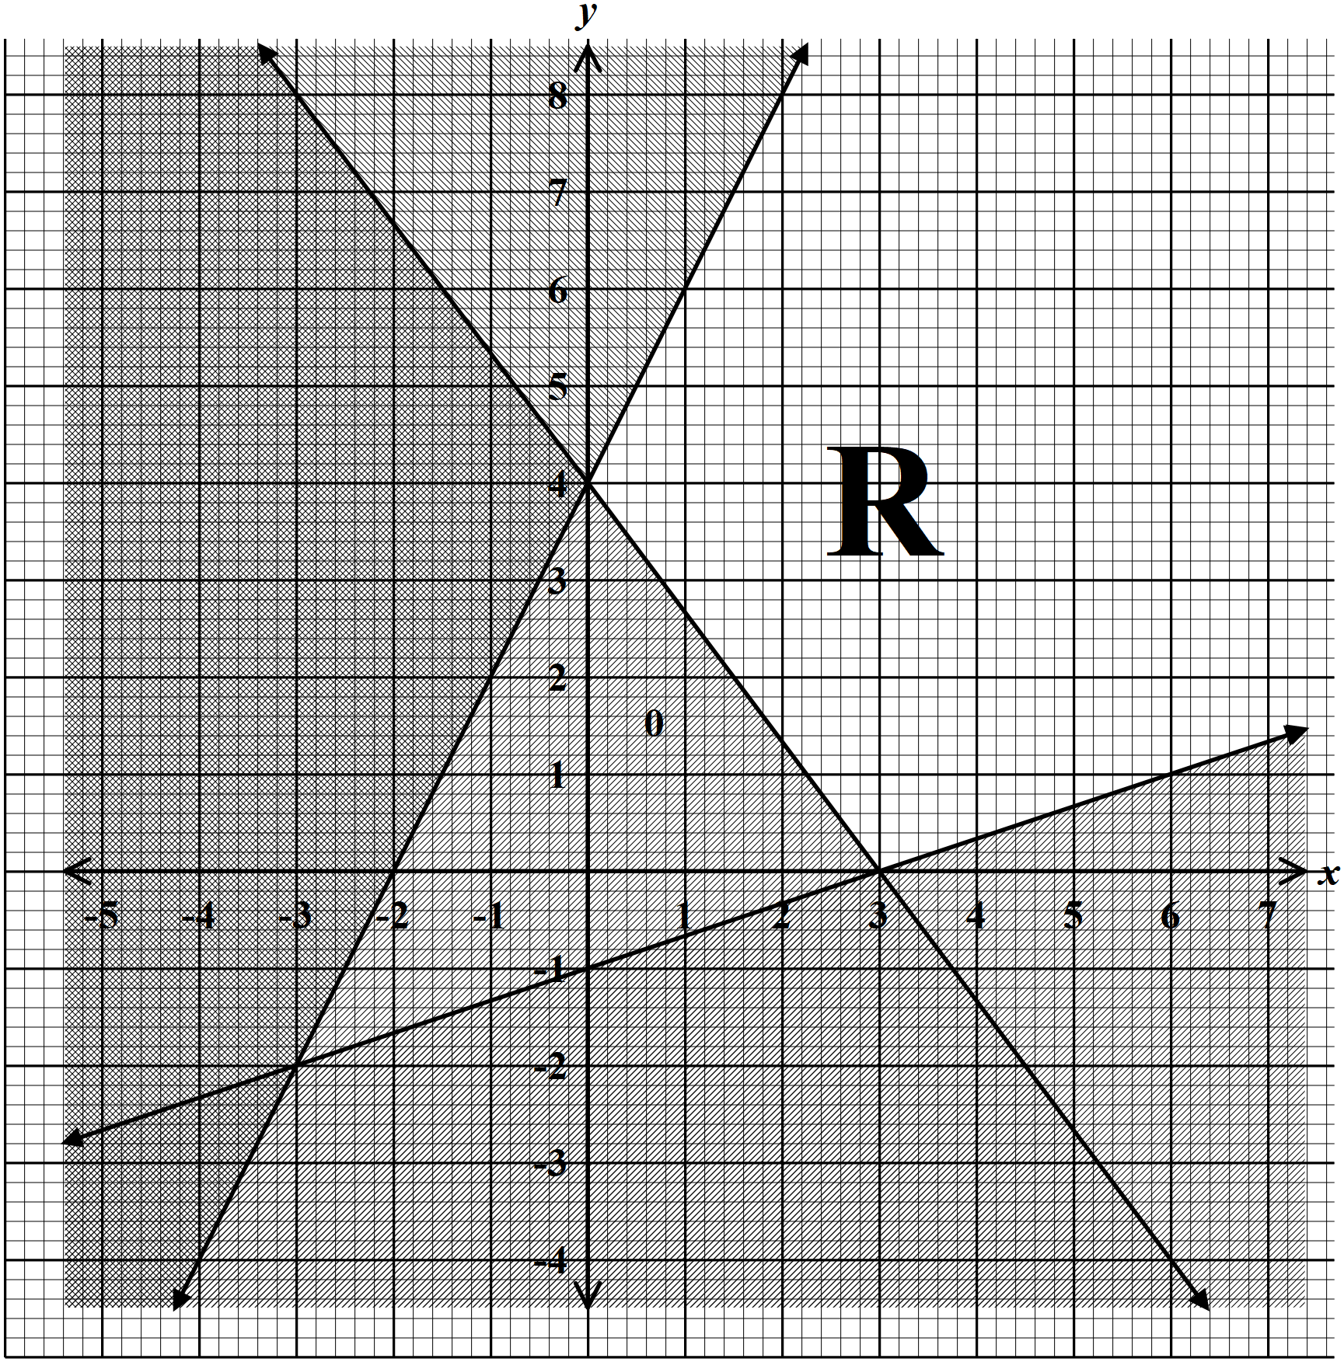13. State the inequalities that satisfy the region defined by R. (3marks)

14. Solve for $θ$ in the equation $\frac{sin⁡(2θ+30)°}{cos⁡(3θ−40)°}=tan45°$ (3marks)

15. The figure below shows a circle PQRS Centre O with SR produced to T.PQ//SR and $∠QSR=55°.$Calculate the size of$∠QRT$. (3 marks)
O
55º
P
S
Q
R
T

16. The scale of a map is 1: 200.Calculate the actual area of a triangular coffee field whose sides are 6cm, 8cm and 10cm on the map. (3 marks)

SECTION 11 (50 MARKS)
Answer only five questions from this section.
17. A tower is on a bearing of 030º from a point P and a distance of 100m.From P, the angle of elevation of the top of the tower is 15º and the angle of depression of the foot of the tower is 1º.
a). Calculate the height of the tower. (4 marks)

b). A point Q is on the same horizontal plane as point P. The tower is on a bearing of 330ºfrom Q and a distance of 70 m. Calculate:
i) The distance from P to Q. (3 marks)

ii) The bearing of P from Q. (3 marks)

18.a) The diagram below shows a bucket in the shape of a frustum of a cone with diameters 36 cm and 24 cm and a vertical height of 28 cm. The bucket contains water such that the diameter of the water surface is 30cm. Calculate the volume of the bucket. (6 marks)

b) If the bucket above has a hole and 1.1 cm³ of water leaks out every 5 seconds and collects in a cylindrical can of base radius and height 10 cm and 25 cm respectively. Calculate how long it takes to fill the cylindrical can. (4 marks)

19. A piece of wire, 18 cm long is cut into two parts. The first part is bent to form the four sides of a rectangle having length x cm and breath 1 cm.
a).State two expressions in terms of x only for the perimeter of the square and the rectangle.(2 mks

b).If the sum of the areas of the square and the rectangle is A cm², show that $A=16−3x+\frac{x^{2}}{4}$
(2 marks)

C). If A $=8{cm}^{2}$, Solve the equation in (b) above for $x,$hence find the possible dimensions of the two pieces of wire. (6 marks)

20. The distance between two towns P and Q is 300 km. A bus started at P at 10.30 am and travelled towards town Q at 80 km/h. After 45 minutes a car started at Q and travelled to town P at x km/h. The car met the bus after 1hour 20 minutes.
a) Determine the value of x. (3 marks)

b) Find the distance from P where the car met the bus. (2 marks)

c) At what time did the car meet the bus? (2 marks)

d) If t a shuttle started at P, 1hour after the car left Q for P. Calculate the speed to the nearest km/h at which the shuttle should be driven in order to arrive at Q at the same time with the bus.
(3 marks)

21.a) Complete the table of values for the equation $y=x^{2 }+3x−6$, given that $−6≤x≤4$. (2marks)
x | -6 | -5 | -4 | -3 | -2 | -1 | 0 | 1 | 2 | 3 | 4
y | 12 |  |  |  |  |  | $$−6$$ |  |  |  | 22
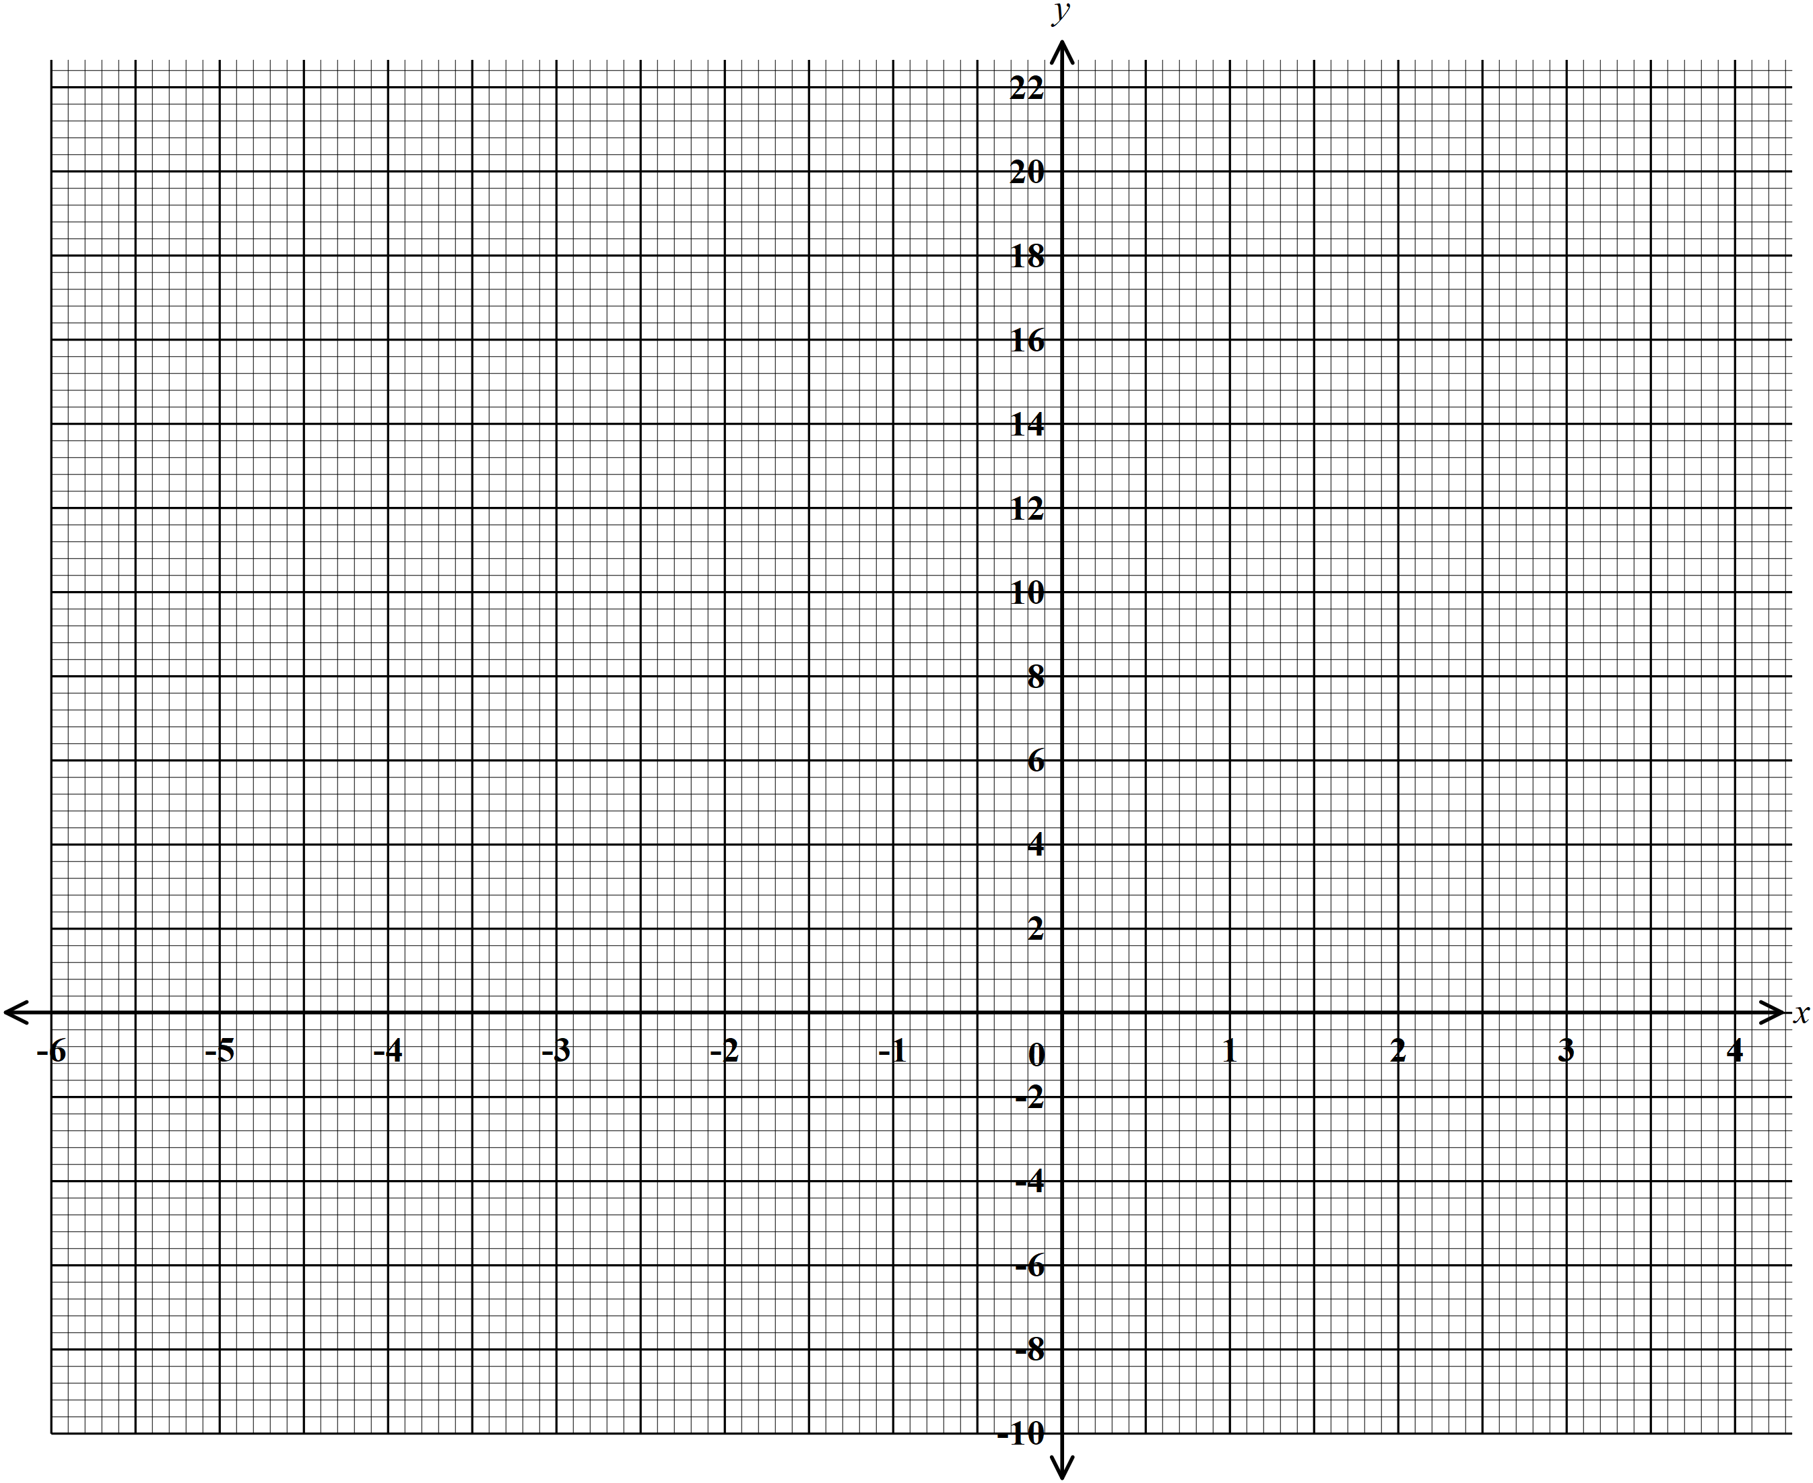

b) Using a scale of 1cm to represent 2 units in both axes, draw the graph of$y=x^{2 }+3x−6$ . (3 marks)

c) Using the graph drawn above Solve the equation
i) $x^{2}+3x−6=0$ (2 marks)

(ii) $x^{2}+3x−2=0$ (3 marks)

22. A Business man is paid a commission of 5% on sales of goods worth over ksh 100,000. He is paid a monthly salary of ksh 15,000 but 2% of his total earning is remitted as tax. In a certain month he sold goods worthy khs 500,000.
a) Calculate his monthly net earnings that month. (5marks)

b) The following month, his monthly salary increased by 20%. His commission was increased to 10% but on goods worth over ksh 200,000. If his total earnings that month was ksh 64,800, Calculate the money received from the sale of goods. (5marks)

23. The coordinates of two points A and B are (2, -3) and (-4, 5) and R is the mid-point of AB.
a) Determine the coordinates of R. (2 marks)

b) Find the equation of a straight line joining A and B, expressing it in the form $y=mx+c$ where m and c are constants. (3 marks)

c) The straight line $L_{1 }which is a$perpendicular bisector of AB meets the X-axis at T. Find the coordinates of T. (3 marks)

d) If the straight line $L_{1 }$is parallel to a line that passes through the point (-1, 6) and (a, 8), find a. (2 marks)

24. Two inlet taps P and Q opened at the same time can fill a tank in $2\frac{1}{2}$ h. The two taps were opened together at the same time and after 1 hour 10 minutes tap Q was closed and P continued alone and filled the tank after a further 4 hours. Find:
a) The fraction of the tank filled by both taps for 1 hour. (1 marks)

b) The fraction of the tank filled by tap P after Q was closed. (2 marks)

c) The time which each tap working alone would have taken to fill the tank. (7 marks)

